Overview:

* This document describes a Memory task for the Deming/Weidmann social skills experiment
* There are three sub-tasks here: *Images, Words,* and *Stories*
* Each sub-task will be administered to individuals sequentially
* Groups face a different challenge. They will have a limited amount of time to memorize all three different sets of stimuli: images; words; and stories – before answering questions about any of the three.
* There are two core ideas here:
  + working memory is limited
  + groups will be more productive when individuals take ownership of different sub-tasks.[1] Groups that collaborate effectively will do better on this task (conditional on the memory ability of individuals).
* The rest of the document is structured as follows

Part 1 describes the three different sub-tests (each of which have multiple forms)

Part 2 describes how the Individual and Group tasks differ

Part 3 has instructions on how to deploy different forms of the sub-tests

## 1. Elements of the task

### 1a) Images

* The basis of this test is the [Cambridge Face Recognition Test](http://www.bbk.ac.uk/psychology/psychologyexperiments/experiments/facememorytest/experiment2.php)[2]. Specifically, we’ll use the items where people are asked to remember 6 “target” faces [they have 20 seconds to do this]. They are then presented with sets of three faces, and have to identify which one is a “target”.

In this test you will learn to recognize six people.

* 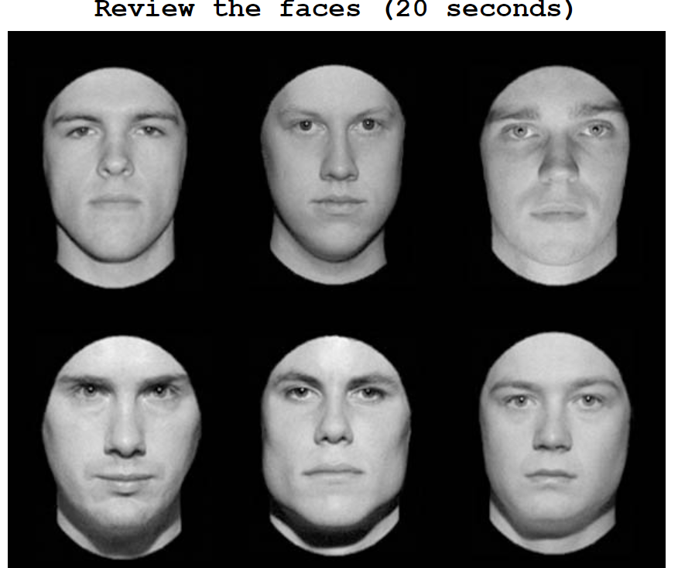

Example items (getting progressively more difficult).

* 1. Which face is one of the six target faces?

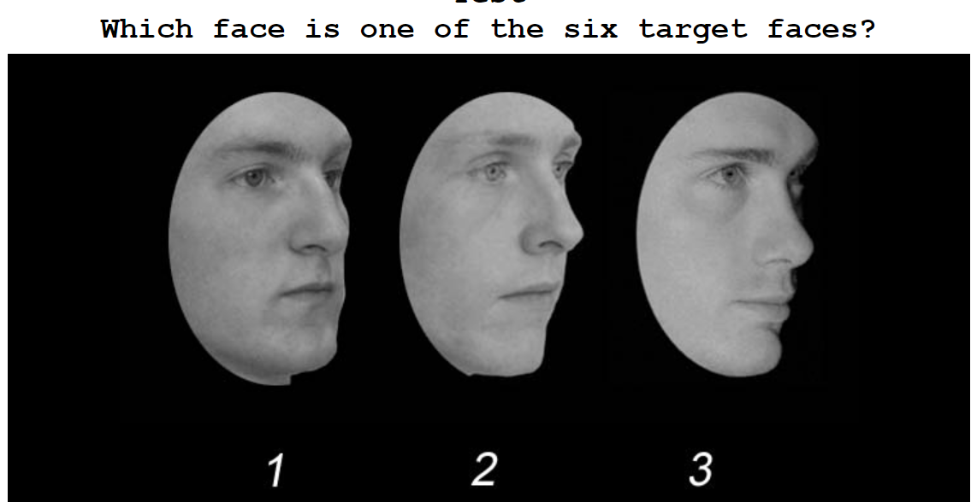

* 1. Which face is one of the six target faces?

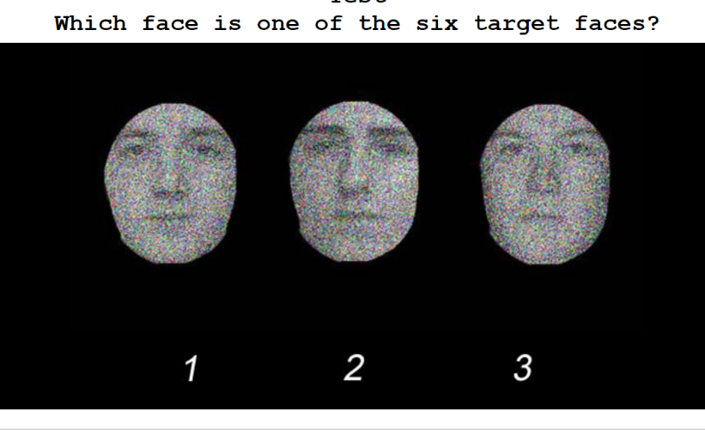

* 1. Which face is one of the six target faces?

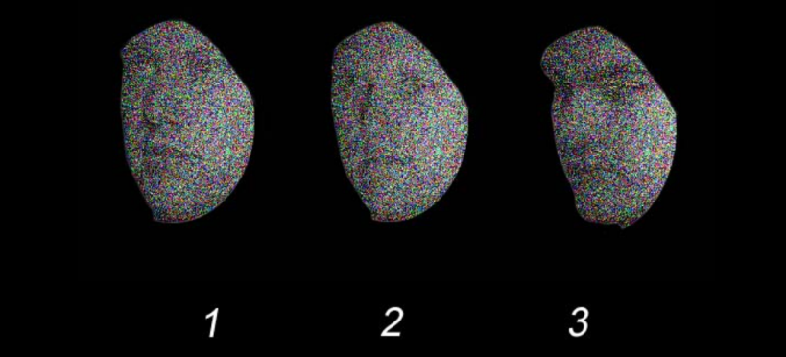

­­­­­­

There are two forms of the “face” test. We also have two equivalent tests where people are asked to remember bikes and cars. We describe how we plan to use these in Part 2.

### 1b) Words

* We present people with a list of words from the [Hopkins Verbal Learning Test](http://static1.squarespace.com/static/548f3b5ce4b0ab0288d52cf5/t/5502073be4b0e85d639f7ec1/1426196283131/Hopkins.pdf). Typically, the words are read to participants. For our experiment, the words will appear on the screen (sequentially).
* The lists have categories, e.g. “four-legged animals, precious stones, human dwellings”

EMERALD

HORSE

TENT

SAPPHIRE

HOTEL

CAVE

OPAL

TIGER

PEARL

COW

HUT

* After viewing the words, participants are presented with 8 questions. Each question has 3 words. They are told to select each of the words that was in fact on the list. Example questions:
* Q1) Which of the following words were on the list [tick all that apply]?
  1. Horse, Ruby, Cave
* Q2) Which of the following words were on the list [tick all that apply]?
  1. Balloon, Coffee, Lion
* Q3) Which of the following words were on the list [tick all that apply]?
  1. House, Opal, Tiger

### 1c) Story

* Participants are presented with a story, then asked questions about it. Often, the presentation is based on a recording.
* **Question: could our platform accommodate an audio recording?**
* Here is an example story:

*STORY A:*

*Anna Thompson of South Boston, employed as a cook in a school cafeteria, reported at the police station that she had been held up on State Street the night before and robbed of $56. She had four small children, the rent was due, and they had not eaten for two days. The police, touched by the woman’s story, collected money for her.*

* After hearing (or reading) the story, participants are asked a set of multiple choice questions (with three possible responses) e.g.:

Q1) What was the woman’s name? [Anna Thompson, Annabelle Tompkins, Anna Tompkins]

Q2) How many children did she have? [4,5,6]

Q3) The robbery occurred on which street [4th, 5th, 6th ]

Q4) How much money was stolen? [$56, $66, $46]

Q5) What did the police do? [Collect money for her; Pay her rent; Collect food for her]

## 2. Administering the Memory Task

### Individual

* As with all our tasks, we first administer it to individuals.
* Each stimulus type is tested sequentially
  1. Images (Images_1 test; faces)
  2. Word list (Wordlist_1; four-legged animals et al)
  3. Story (Story_1 test; Anna Thompson)
* After completing all three, ***we need to tell people which test they performed best on***. This could be useful in helping to get teams to sub-task differentiate.

### Group

* The group task is different. During the “memorizing” period, each group member can focus on whatever element they like (images, words, story). i.e. on their own laptop, they can click on one of three buttons:



* The group as a whole has [50] seconds to memorize all three stimuli.
  1. After people click on an option, they can always go ‘BACK’ and return to this options page, and select a different type of stimulus.
* At the end of the 50 seconds, we ask the group questions about any of the three stimuli. **They have to answer as a group** [i.e. one person responds for everyone].

## 3. Administering the Memory Task

Instructions are given the powerpoint files. Specifically:

* For the Individual Test see “Individual_Memory_Test.pptx”.
  1. Images_1 (Cambridge Faces)
  2. Words_1 (four-legged animals et al)
  3. Story (Anna Thompson)
* For the first Group Assignment, see “Group1_Memory_Test.pptx”
  1. Images_2 (Cars!)
  2. Words_2 (Drinks, Weapons, Kitchen utensils)
  3. Story (Baytown shopping survey)
* Then, for the Second Group Assignment, we have Group2_Memory_Test.pptx [NOT ATTACHED]
  1. Images_3 (Faces, set A)
  2. Words_3 (Instruments, flavours, fuels)
  3. Story 3 (Michael Simpson)
* Then, for the final Group Assignment, we have Group3_Memory_Test.pptx [NOT ATTACHED]
  1. Images_4 (Bikes)
  2. Words_4 (Birds, Hardware, Clothes)
  3. Story 4 (Joe Garcia)

1. See, e.g. [Baumeister](https://www.ncbi.nlm.nih.gov/pubmed/25936575) (2016)
2. For psychometric information see [here](https://www-sciencedirect-com.ezp-prod1.hul.harvard.edu/science/article/pii/S0028393205002496#fig1).